Assignment: Wireless Networking

1. Three Popular Wi-Fi Standards
Standard | Band | Max Speed | Key Difference
802.11n | 2.4 & 5 GHz | 600 Mbps | Supports both bands
802.11ac | 5 GHz | 3.5 Gbps | Faster, 5 GHz only
802.11ax | 2.4/5 GHz | 9.6 Gbps | Higher speed and efficiency

2. Network Diagram
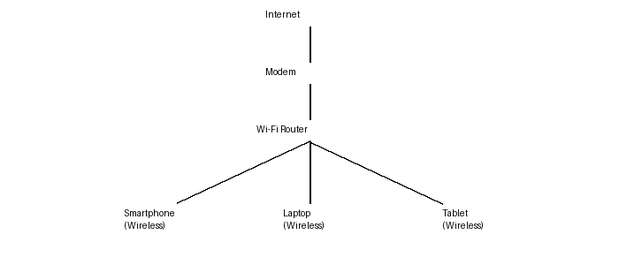

3. Example Wi-Fi Scan
SSID | Signal | Security
Home_WiFi | -42 dBm | WPA3
Office_Net | -60 dBm | WPA2
Cafe_FreeWiFi | -75 dBm | Open
I would choose Home_WiFi because it has the strongest signal and uses WPA3 security.

4. SSID Hiding
SSID hiding means the router does not broadcast its network name. Advantage: reduces visibility to casual users. Disadvantage: it is not real security because the SSID can still be discovered with scanning tools, and connecting devices is less convenient.

